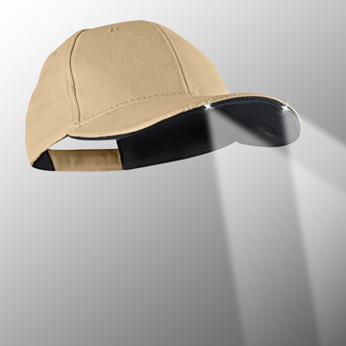
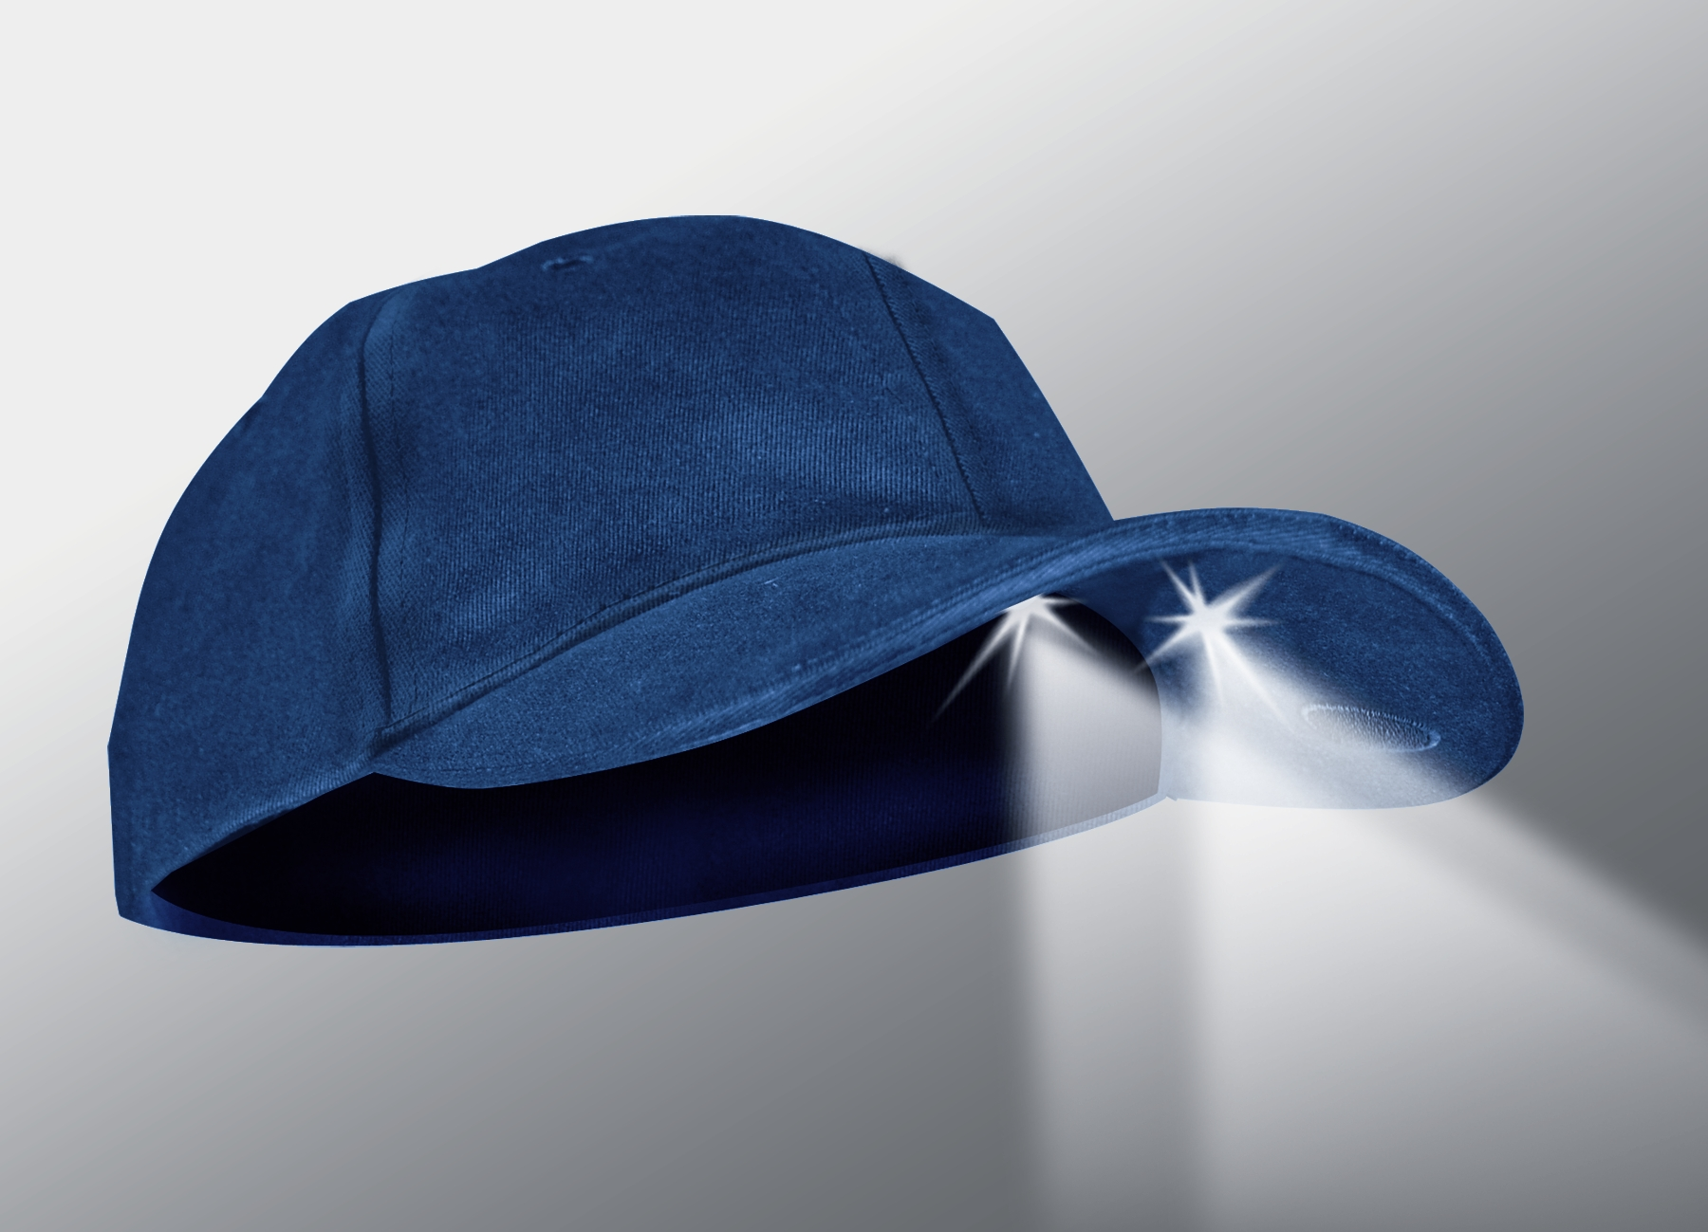

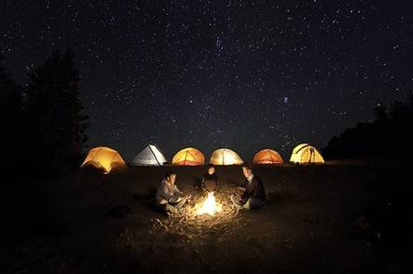
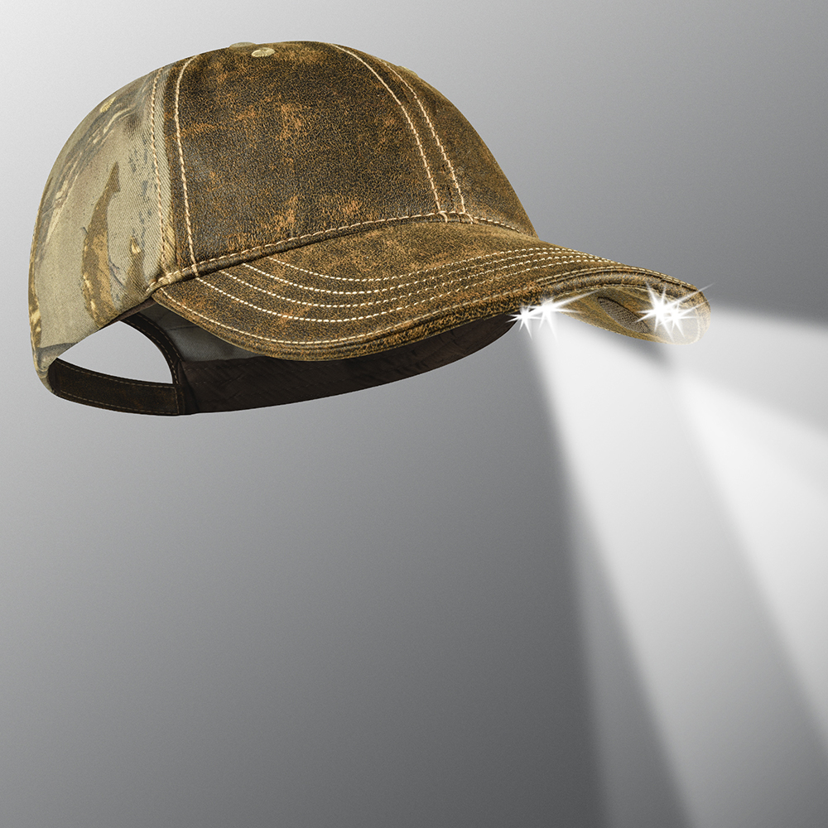

VISIT OUR WEBSITE WWW.PANTHERVISIONPROMO.COM
TO SEE THE FULL LINE OF LIGHTED PRODUCTS
OR CALL 847.783.5900 x 116 FOR MORE INFORMATION

VISIT OUR WEBSITE WWW.PANTHERVISIONPROMO.COM
TO SEE THE FULL LINE OF LIGHTED PRODUCTS
OR CALL 847.783.5900 x 116 FOR MORE INFORMATION

Whether chasing fireflies, camping
or watching fireworks let the
fun continue with a CAPLIGHT 2000®,
POWERCAP® Stealth 2500 or 2575.

The “ultimate hands-free flashlight”, with
high and low beam directional lights for
distance and up-close tasks.

Easy on/off switch concealed under brim.
50+ hours continuous battery life.

Because of the many uses, POWERCAP® delivers low cost per impressions for your customer.

VISIT OUR WEBSITE WWW.PANTHERVISIONPROMO.COM
TO SEE THE FULL LINE OF LIGHTED PRODUCTS
OR CALL 847.783.5900 x 116 FOR MORE INFORMATION

VISIT OUR WEBSITE WWW.PANTHERVISIONPROMO.COM
TO SEE THE FULL LINE OF LIGHTED PRODUCTS
OR CALL 847.783.5900 x 116 FOR MORE INFORMATION

VISIT OUR WEBSITE WWW.PANTHERVISIONPROMO.COM
TO SEE THE FULL LINE OF LIGHTED PRODUCTS
OR CALL 847.783.5900 x 116 FOR MORE INFORMATION

Summer Celebrations
Don’t need to end when it gets dark

Caplight in Tan
CL2-174
Stealth 2575 Weathered
Front REALTREE Xtra back
PS4-7097
Available in a variety of colors
fabrics and styles
ASI 75825 SAGE 68668 PPAI 318255

VISIT OUR WEBSITE WWW.PANTHERVISIONPROMO.COM
TO SEE THE FULL LINE OF LIGHTED PRODUCTS
OR CALL 847.783.5900 x 116 FOR MORE INFORMATION

VISIT OUR WEBSITE WWW.PANTHERVISIONPROMO.COM
TO SEE THE FULL LINE OF LIGHTED PRODUCTS
OR CALL 847.783.5900 x 116 FOR MORE INFORMATION

Stealth 2500 in Navy
PS2-118
Add your logo here

VISIT OUR WEBSITE WWW.PANTHERVISIONPROMO.COM
TO SEE THE FULL LINE OF LIGHTED PRODUCTS
OR CALL 847.783.5900 x 116 FOR MORE INFORMATION

